**Alibaba’s TaoBao**

**1st Attempted Research**

Our mission of this 1st attempted research is to have an overview of TaoBao from different aspects, and the timeline of TaoBao since first launched to current point and the future.

***Huy’s thought*** *on TaoBao: By doing this research, now I know why, and I can say that TaoBao is the largest C2C marketplace in the World. TaoBao is the heaven for shopping online; everything is linked together with a lot of sub-domain. The design may make English readers confusing but in the Chinese eyes, it is all convenient and user friendly.*



**How Alibaba’s Ecosystem changed people’s life**

Mr. Wong, a 39-year-old entrepreneur who lives in Hong Kong, is a regular shopper on Taobao, China’s largest online marketplace run by Alibaba. His most recent purchase was a black T-shirt that said “New York” in white letters, which cost a little over $3. The transaction took place between Mr. Wong and the merchant who sold the T-shirt on Taobao, which serves as a platform where sellers and shoppers find each other. The story of Mr Wong is just one of million stories which got the life changed since Alibaba’s platforms are launched. TaoBao currently taking 95% of the C2C market of China.

**Overview Taobao & Tmall**

*Mission: Make it easier to do business anywhere*

*Alibaba: help everyone doing ecommerce (1999)*

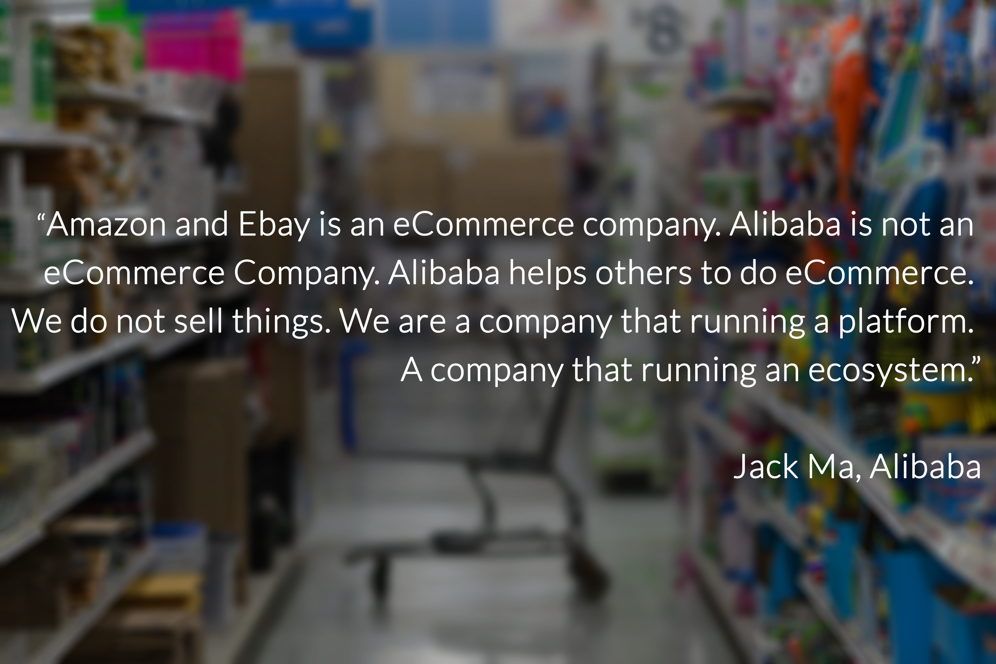

Last year, Taobao and Tmall together surpassed $160 billion in transactions and accounted for the majority of the company’s revenue.

While almost anyone can become a seller on Taobao with little upfront cost, Tmall is a more exclusive site. Brands and authorized distributors pay deposits to open storefronts after going through a [**stringent verification process**](http://online.wsj.com/article/SB10001424127887323968704578649394254345564.html).

* TaoBao: Largest Online shopping destination with China’s most popular mobile commerce app.
* Tmall: a website that hosts storefronts for many brands like Nike Inc. and Gap Inc.

**1. Taobao’s history (Search for treasure)**

The platform is launched in May 2003 to prevent eBay from entering the C2C market. 2003, eBay entered China and acquired almost all the ecommerce sites in China at that time including EachNet.com (Chinese Language version of eBay), the highest user online marketplace at that time.

|  |  |  |  |
| --- | --- | --- | --- |
| External Analysis (PEST) | | | |
| Political/Legal: | **Economic:** | **Socialcultural:** | **Technological:** |
| Single Party Government (Communist), business is based on relationship. | Fastest growing economy in the World, rising middle class, young age. | Relationship and referral-based business. Cash-based society | 200 million internet users, growing everyday. Huge growth in ecommerce business. |

**Challenges:** One big challenge is [how to adapt its business](http://online.wsj.com/article/SB10001424127887323455104579016493516583928.html?mod=wsj_share_tweet) as more Chinese consumers use mobile devices.

**Versus WeChat:** As Alibaba tries to lure smartphone users, it [faces competition](http://blogs.wsj.com/chinarealtime/2013/08/01/alibaba-bans-sellers-from-using-wechat) from other Chinese Internet giants such as [Tencent Holdings](http://online.wsj.com/public/quotes/main.html?type=djn&symbol=TCEHY) Ltd., which is also trying to beef up its mobile and online commerce capabilities. WeChat smartphone messaging app has 236 million active users. Last month, it added electronic payment features to the app, a step toward turning the communication tool into an e-commerce platform.

Forrester Research analyst Bryan Wang says Tencent has a lot of potential because WeChat is a “very sticky” platform – many people use it all day long to communicate with their friends and family members. If the company can successfully integrate other services into WeChat, it could evolve into a major e-commerce competitor, Mr. Wang says.

**2. Taobao vs eBay, the war of C2C (How Taobao is different):**

Jack Ma and his team worked day and night for a new secret project. May 2003, Alibaba Group launched TaoBao with the mission of developing ecommerce for individual, providing good services for them, not about making money.

**The Strategy to play with the bigger rival:**

The recipe of TaoBao in 2003 to compete with eBay is simple. To build the website which give the better fit the China’s market. The 2 have a really different strategy at that time. eBay moved to link the China’s site to their global platform, discontinued the features that popular and common usage with Chinese users. TaoBao is developing the website which is customized for the China’s market, adding features to help users build trust and make friends online. The website is built really user friendly and more human touch for Chinese users.

**The Battle of Web Design:**

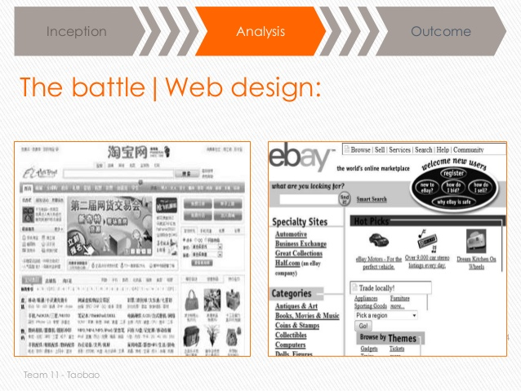

To eBay western manager, TaoBao is too **cute and flashy**. The website included locally popular features   
such as live chat and message board which encourage members to build relationships of the community. The result of it is more and more online shoppers joined TaoBao quickly while eBay start its struggles.

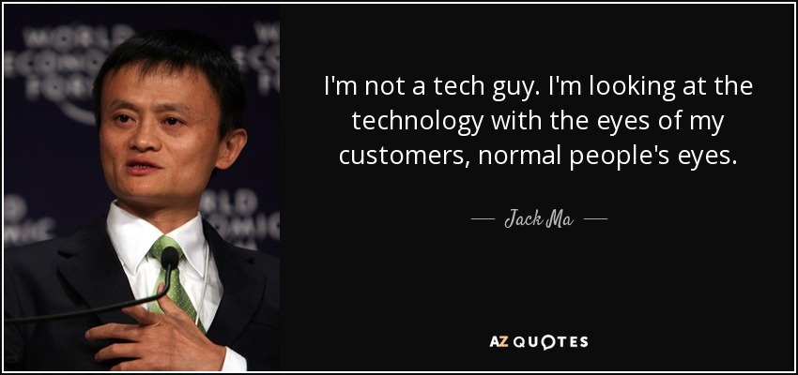

**No Transaction Fee, it is all-free:**

Taobao, which doesn’t charge transaction fees, makes money mainly through advertising purchased by merchants who use the site. That can generate a lot of revenue because there are about 7 million merchants –- mostly small businesses — using Taobao. Many merchants spend money on ads to make their products more visible, since there are more than 800 million items on Taobao.

**3. Why eBay failed in China:**

**Understand the consumer, what do they want?**

First, eBay failed to recognize that the Chinese market and the business environment are very different from that of the West. EBay sent a German manager to lead the China operation and brought in a chief technology officer from the United States. Neither one spoke Chinese or understood the local market. It was eBay’s biggest mistake.

**Wrong Market Approach Strategy:**

Second, because the top management team didn’t understand the local market, they spent a lot of money doing the wrong things, such as advertising on the Internet in a country where small businesses didn’t use the Internet. The fact that eBay had a strong brand in the United States didn’t mean it would be a strong brand in China.

**eBay tried to globalize even they have not gotten the local:**Third, rather than adapt products and services to local customers, eBay stuck to its “global platform,” which again did not fit local customers’ tastes and preferences.

**4. Taobao Account:**

Same account for selling & buying. Make a new account or/and connect with Weibo and Alipay!

**Buying:**

1. (Need to be verified for real) 3 levels of Authentication, each have limitations except the 3rd level which gives the most freedom.
   1. ID number
   2. photo
   3. documents get reviewed by customer service staff
2. (Need it to make account) taiwanese/hong kong/mainland phone number
3. (Need it to make account) chinese mainland address.
4. chinese credit card or bank account.

**Selling ( 2nd hand things):**

1. Dont need to authenticate again.
2. All 2nd hand things from users go here. <https://2.taobao.com/?spm=0.0.0.0.TKq6vH>
3. Sell anything you have on idle for free, they encourage you to post it( dont require a store, just post it on 闲鱼 ）

**Selling ( new things/opening a store):**

1. One ID = One shop
2. Once applied, cannot be cancelled
3. takes up 1 to 3 business days
4. choose store type
5. apply to authenticate shop
6. set up shop functionalities including messaging.

**Two types of shops:**

1. Individual
   1. free selling tools ( did not elaborate on the web <https://openshop.taobao.com/openshop/welcome.htm> )
   2. free picture space
   3. create low threshold marketing campaigns
2. Enterprise
   1. more product posts
   2. more prosperous management
   3. display more awards

**5. Taobao Features (Focus on developing community of users):**

* Chat within users
* Save pages
* save shops
* follow shops
* Like and repost
* make own post of things within taobao
* worth buying button
* history
* hongbao – discounts
* and a tons of other features.

**6. Sub domains in Taobao**

* guang. -- for girls stuff only
* love. -- new things to like
* -- second stuff only
* uz. -- trending shops only
* g. -- global taobao

**7. Taobao Search Engine:**

* Advance search
* all pages
* shops
* “my search”
* tmall search
* search from top selling shops
* search from favourite shops
* separate things by gender
* search by category
* search 2nd hand stuff
* search from shops that you bought before
* search from shops you stored
* search from shops your friends bought from

**8. Taobao UX:**

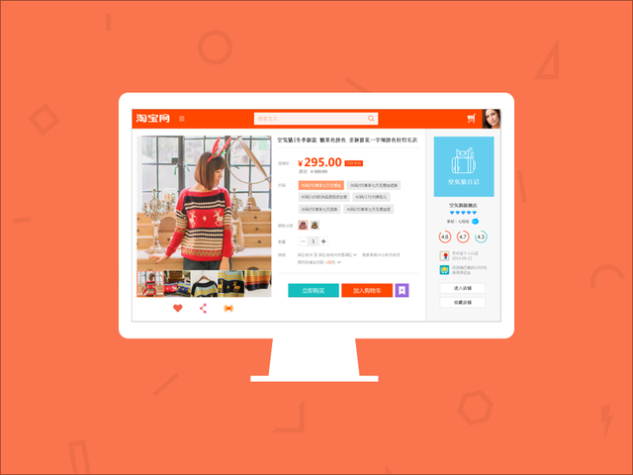

**Objective:**  Make people linger on their website, as a form of entertainment.

**Method:**

(1) New things everyday

(2) A lot collection of things

(3) A lot of ways to sort items, mostly items are appeared on user’s account based on user’s gender

(4) Using hot tone colors

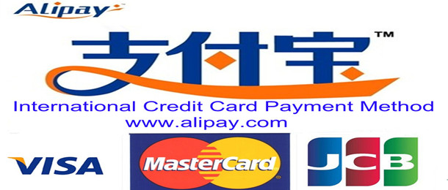**9. TaoBao Payment Methods:**

* Chinese TaoBao: All through Alipay (Separated 3rd party payment gateway). Alipay supports all global issuers credit and debit like Visa, Master, JCB (Except Washington, USA).
* Global TaoBao:
  + **Into Alipay:** Overseas users can choose to pay by their global issuers like VISA, Masrer and JCB international credit cards in TaoBao. International cards refund time is generally 7 days.
  + **Quick Payment:** Credit card payment is a shortcut to the credit card associated with Alipay account, every payment need only enter the mobile phone to get "one-time password" and pay Alipay account password security and easy payment. Currently supports Hong Kong, Macao and Hong Kong, BOC Credit Card issued by AEON credit card.